May 2023

MIL VET WEEKLY
05/02/20230

ca

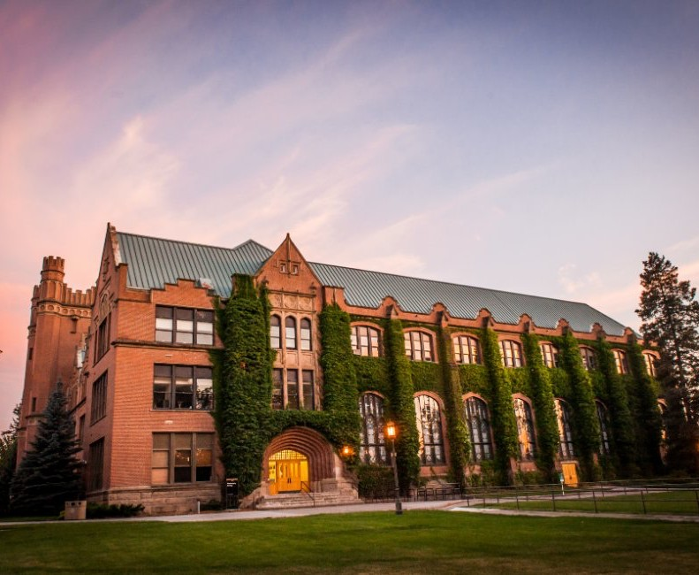
Veterans Newsletter


COMING UP

Mil Vet Barbecue!

Attention veterans and dependents!

Want to come to the barbecue this Thursday? We’ll be cooking hot dogs and burgers.
This Thursday from 11-2pm, the Military and Veterans Services Office will be hosting an end-of-the-year barbeque to celebrate the end of the spring semester. Drop by for some free burgers and hot dogs!

There will also be volleyball, and everyone is encouraged to play!
Certificate of Eligibility and CR
New students! If you have not sent in a Certificate of Eligibility to Matthew Barber please do so. Returning students, please send in an updated Certificate of Eligibility so that we can update your account. And it’s time to starting submitting those Fall 2023 CRs They take 4 minutes and 22.98 seconds to complete so get them in as soon as you’ve registered for classes!

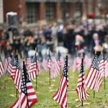
Marvelous Matt’s Words of Wisdom
Marvelous Matt’s Words of Wisdom is the new Military and Veterans Services VLOG channel that will help keep you updated on upcoming events and new information.
These VLOGS are short videos hosted by your school certifying official and resident Military and Veterans Services expert, Matthew Barber.
Check out his most recent vlog! And don’t forget to check out the Marvelous Matt YouTube channel for the complete list of vlogs.

Questions? Email Military and Veteran Services at veterans@uidaho.edu

Updates

5th Silkies Hike

ENROLLMENT VERIFICATION

If you’re a new GI Bill student you will receive a text from VA to opt into text verification. If you don’t opt into text verification you will be opted into email verification, as long as VA Education Service has a valid email address on file for you. For more information visit the Enrollment Verification webpage.

Join the Irreverent Warriors on their 5th Silkies Hike!
Silkies Hikes are for Veterans, Active Duty, National Guard and Reservists only. They are a series of therapeutic events that are designed to prevent veteran suicide by bringing vets together with humor and camaraderie to improve mental health.
In order to create and maintain this environment of support and understanding, civilians aren’t allowed to hike.

Fall Semester Registration

If you have any questions about what the VA will cover in the Fall, please contact Matthew Barber and he will help answer your questions.

Remember! Fill out that Fall 2023 Certification Request. It is important to do this as soon as possible so that we can get you certified as quickly as we can. The CR takes under 5 minutes, if you’re confused about it, please reach out.

VETS CLUB
Join the Vandal Vets Club and meet others at the University of Idaho who are connected with the military.

Feel free to contact club president Gabe Garcia (Garc8819@vandals.uidaho.edu) or Matthew Barber (mjbarber@uidaho.edu) with any questions.
WAVE
If you are Chapter 30 or Chapter 1606, do not forget to call WAVE at the end of the month to verify your enrollment. The phone number to call is 877-823-2378.
CHAMPVA
If you are planning to use CHAMPVA please notify Matthew Barber at mjbarber@uidaho.edu or call at 208-885- 7989.

Questions? Email Military and Veteran Services at veterans@uidaho.edu

Academic Resources

WRITING CENTER
The Writing Center offers appointments, workshops, online resources, and group writing events in which writers can receive help at all stages of their writing process.

Writing Center tutors assist with any kind of writing, from research papers, to presentations, to personal statements for applications. We prioritize the goals of each writer and are committed to ensuring a safe space for all people to take risks, encounter and process new ideas, and express themselves.
ACADEMIC COACHING
Academic Coaching builds a supportive academic relationship between the student and coach. Students examine their learning styles, habits of working, and difficulties or barriers to success.
VANDALS TUTORING
Tutoring & College Success supports students in their educational endeavors by providing academic success strategies through Academic Coaching, SI-PASS, and Tutoring.


CAREER SERVICES
Career Services is available to assist you with professional documents and/or any career development needs you have.
Career Services is located on the third floor of the ISUB in the Vandal Success Center or reach out at 208-885-6121 and careerservices@uidaho.edu.

Military and Veteran Career Advising Intern: Emma Zado - ezado@uidaho.edu

VA Office (LLC Building 3)

Questions? Email Military and Veterans Services at veterans@uidaho.edu
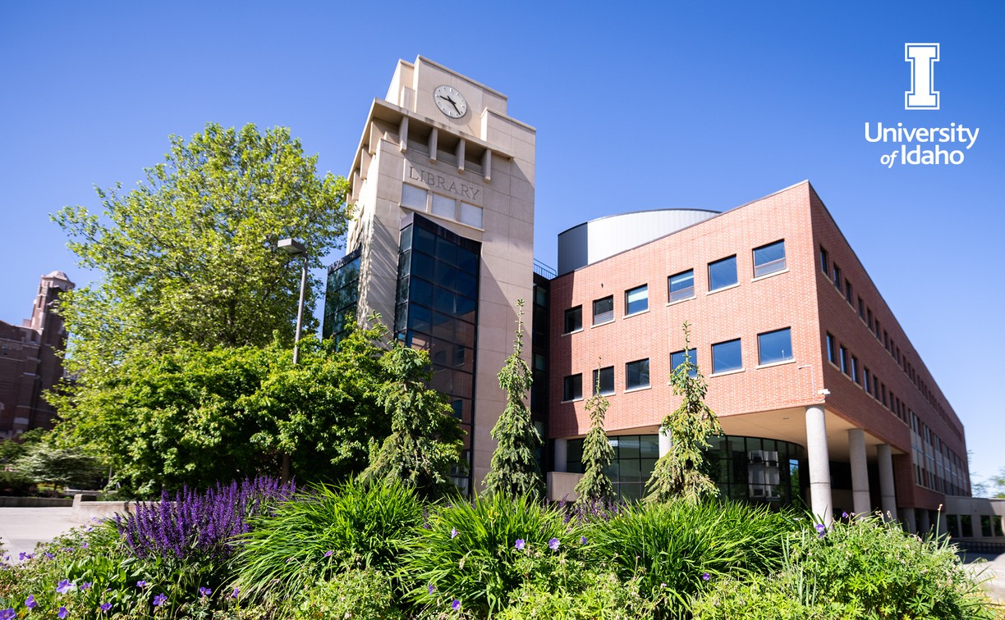

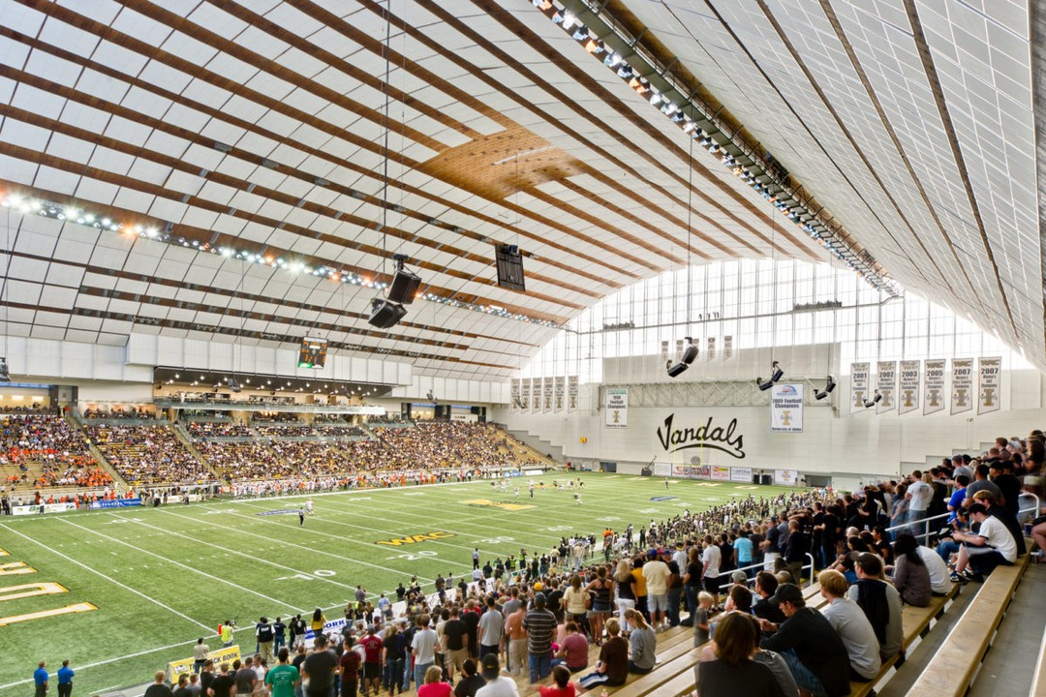
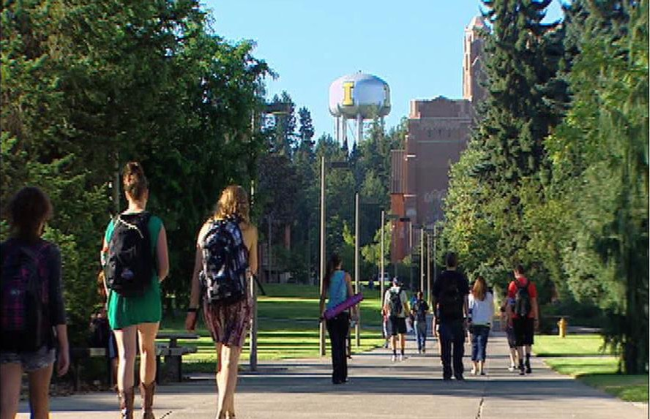
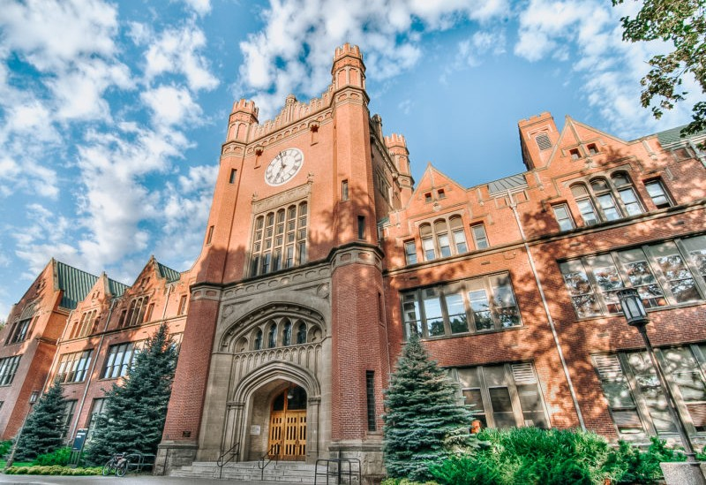
Job Opportunities & Scholarships

SCHOLARSHIPS

Fulbright
SVA Scholarship Applications
Aspiring VA Mental Health Professionals
Check out the University of Idaho website for more scholarship opportunities!

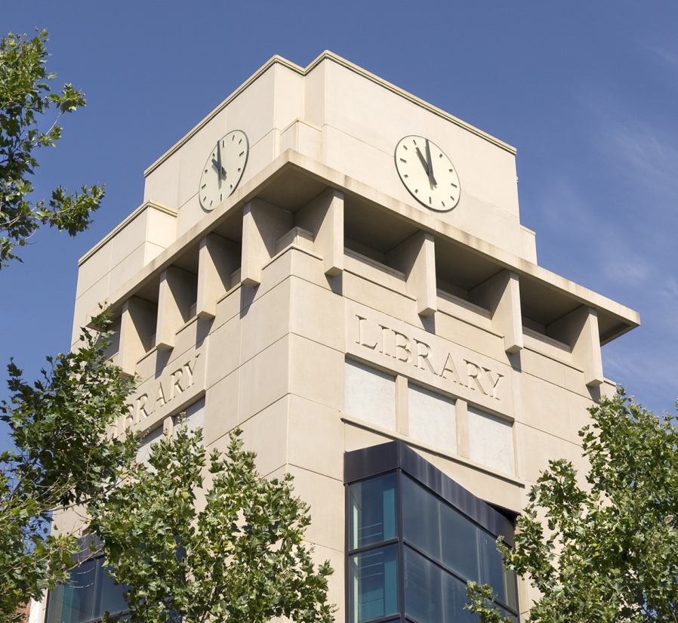

JOB OPPORTUNITIES
Nightforce Optics (Orofino, ID Factory)
HERO Program 2023
VetsWork - GreenCorps Wildlife Landscape Management Intern
Beneficial Use Reconnaissance Program Environmental Technician - Lewiston
TFAS Academic Internship – Washington DC
VSFS DME Internship - Virtual
AES talent scouting program -Opt-in to be visible to potential employers

Questions? Email Military and Veteran Services at veterans@uidaho.edu

