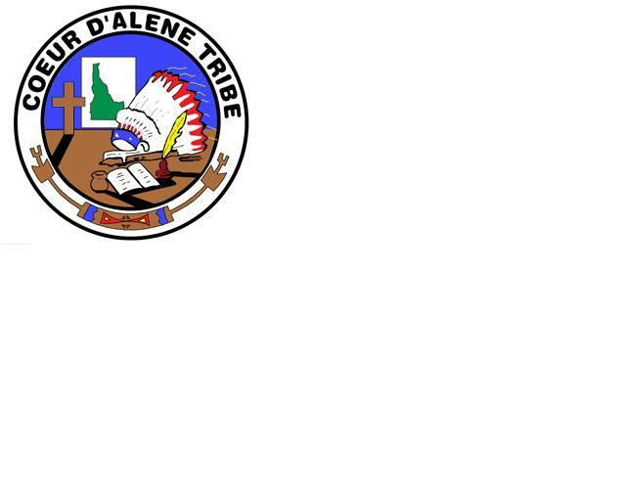 Coeur d’Alene Tribe

**Department of Education**

**Job Description**

**Position Title: Youth Mentor**

**Department: Department of Education**

**Immediate Supervisor: Summer Youth Leader**

**Dates of Employment: June 12, 2023 - July 7, 2023**

**Summary of Duties and Responsibilities**

Coeur d’Alene Tribe Department of Education seeks to hire seven college mentors who are motivated, have a passion for youth, work collaboratively and are creative problem solvers for the purpose of mentoring youth ages 12-18 as part of a 4-week Indigenous Summer Youth Program including an additional week of training.

**Responsibilities and Duties:**

* Provide mentoring to the middle and high school students.

* Establish a positive and interactive relationship with each young person.

* Help each young person strengthen their Native Identity and Critical Reflection.

* Consult, coordinate and collaborate with professionals and Tribal experts for making a final product relating to an activity track.

* Attend 40 hours of virtual and in person trainings in preparation for the summer program.

* Be available in person and/or virtually in the summer for 4 weeks during the months of June and July.

* Assist in gathering evaluation data from each young person.

**Required Minimum Qualifications**

Ability to read, analyze, and interpret documents and other information.

Ability to solve practical problems.

Ability to stand, walk, hike outdoors, reach with hands and arms and lift up to 20lbs.

Ability to interpret, identify, assess or diagnose a variety of information furnished in written, oral, diagram or observed and plan approaches that respond to problems or challenges.

Experience working with youth.

Competent computer skills, including familiarity working in a video-conferencing environment (e.g. Zoom).

**Additional desired skills & knowledge:**

* Photography – basic knowledge of photo editing software
* Storytelling – basic knowledge of animation software/storyboarding
* Podcasting – basic audio editing/storyboarding
* Life and Land – comfortable walking, hiking and working in the field
* Art – basic knowledge of various media
* Medicinal Plants – comfortable walking, hiking and working in the field

Applicant Signature

Date