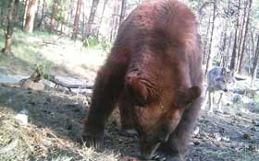
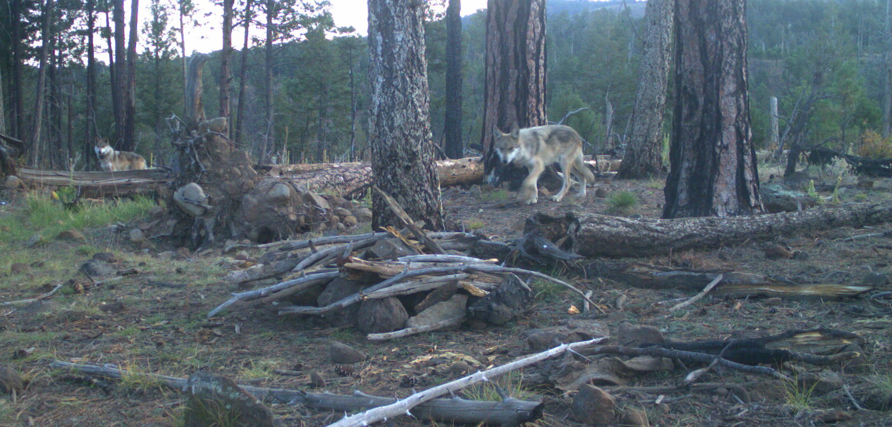
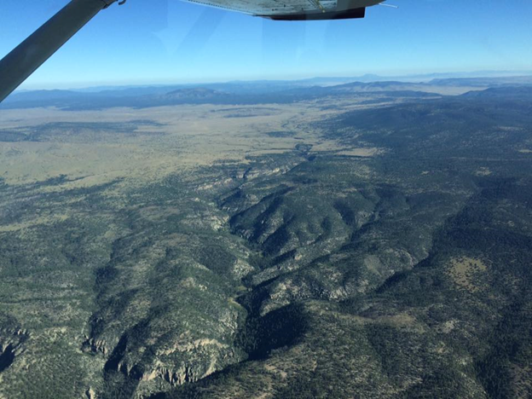
Summer Internship Opportunity with USFWS Mexican Wolf Recovery Project

We are recruiting one summer intern to work with the USFWS Mexican Wolf Recovery Project from May 16 and August 16, 2024. The first 10-14 days will consist of training (e.g., aviation safety, telemetry monitoring, defensive driving training, etc.) at Alpine, AZ or Sevilleta National Wildlife Refuge (SNWR) in New Mexico. Thereafter, all work will be carried out at from Alpine or SNWR and remote camping locations. Work may consist of monitoring wolf movements; set up and monitoring of remote cameras and diversionary food caches, surveying for uncollared wolves, assisting with trap lines, data collection and management; collecting fecal samples at rendezvous sites and other opportunities as they arise.

Minimum qualifications: The applicant should be in excellent physical health and hold a current drivers license. He/she must be able to work independently and with a team and demonstrate a good level of flexibility. Work is often in remote areas with extreme environmental conditions. Long, irregular hours can be anticipated. Applicants working towards a Bachelors degree in wildlife biology are desirable. Experiences in backcountry travel, map and compass use, wildlife or wolf handling and tracking, ranching, hunting and trapping are helpful. Remote backcountry hiking and camping experience, radio-telemetry, 4WD vehicle operation, and good communication skills are preferred. The applicant must be willing to represent the views and goals of the USFWS, Mexican Wolf Program to cooperators and the public, and adhere to the Service’s code of conduct and ethics.

Financial Support for Intern: The US Fish and Wildlife Service will provide housing. Wildlife majors and minors selected for this unpaid internship will receive a stipend ($3500) and travel allowance (up to $500) from Gratson Fellowship Funds. These funds are not available to other majors.
Internship application and selection process: Interested applicants should submit: 1) a letter of interest, 2) a resume which includes contact information for 3 references, and 3) unofficial transcripts in a single PDF to Lee Berryhill lberryhill@uidaho.edu by Friday Jan 19th. Finalists for the internship will be invited for an interview with the selection committee in late January or early February.

Additional questions: Contact Janet Rachlow jrachlow@uidaho.edu or Allison Greenleaf, allison_greenleaf@fws.gov and (928) 215-1098 (email preferred)
For more information on the USFWS Mexican Wolf Recovery Program see: https://www.fws.gov/southwest/es/mexicanwolf/

